Experiment 9 M. Devarajulu
Aim 192212058
To implement the Travelling Salesman Problem (TSP) using Python
Algorithm
- Represent the cities and distances using a cost matrix.
- Fix the starting city.
- Generate all possible routes (permutations) of the remaining cities.
- Calculate the total cost of each route, including returning to the starting city.
- Compare the costs of all routes.
- Display the route with the minimum cost.
Program
from itertools import permutations

# Function to solve TSP
def travelling_salesman(cost_matrix, start):
n = len(cost_matrix)
cities = []

# Create list of cities excluding the starting city
for i in range(n):
if i != start:
cities.append(i)

min_cost = float('inf')
best_path = ()

# Generate all possible paths
for path in permutations(cities):
current_cost = 0
k = start

# Calculate path cost
for city in path:
current_cost += cost_matrix[k][city]
k = city

# Return to starting city
current_cost += cost_matrix[k][start]

# Update minimum cost
if current_cost < min_cost:
min_cost = current_cost
best_path = path

# Display result
print("Minimum Cost =", min_cost)
print("Optimal Path =", start, end=" ")

for city in best_path:
print("->", city, end=" ")

print("->", start)

# Cost Matrix
cost_matrix = [
[0, 10, 15, 20],
[10, 0, 35, 25],
[15, 35, 0, 30],
[20, 25, 30, 0]
]

# Starting city
start = 0

# Call function
travelling_salesman(cost_matrix, start)

Output

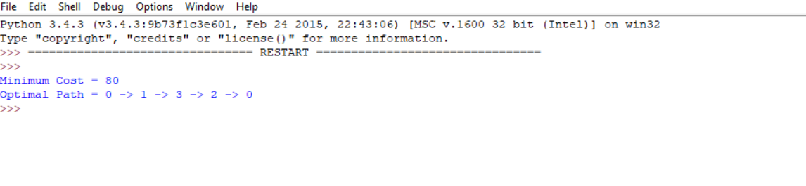

Result
The program successfully solves the Travelling Salesman Problem (TSP) by checking all possible routes and finding the route with the minimum travel cost.
- Minimum Cost: 80
- Optimal Path: 0 → 1 → 3 → 2 → 0

